Maryland, Delaware and District of Columbia
Elks Association Workshop
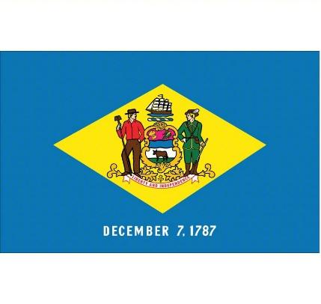
Hosted by Pocomoke City Elks Lodge #1624
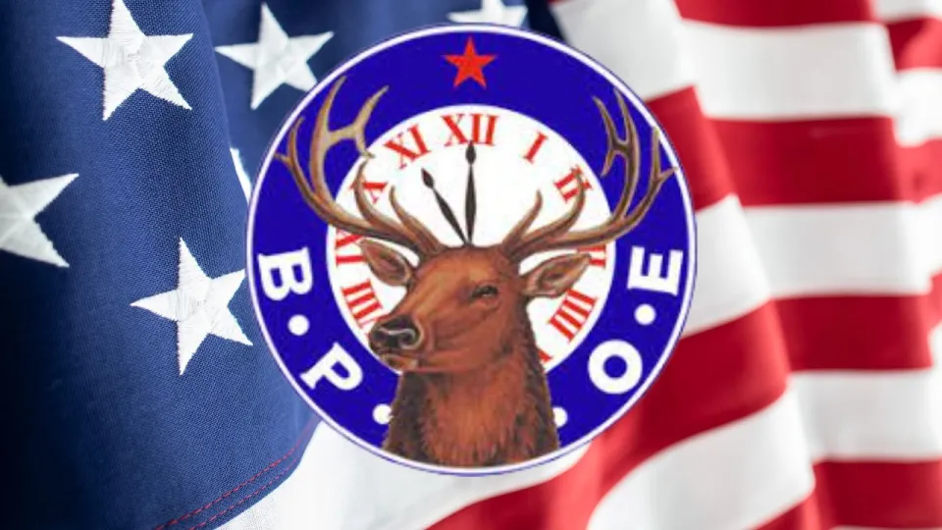Welcoming Grand Exalted Ruler Randy Shook
“WE ARE THE ELKS”

Exalted Ruler Andy Clarke welcomes members of the MD, DE, and DC Elks Association to:
“The friendliest town on the Eastern Shore”
Pocomoke City!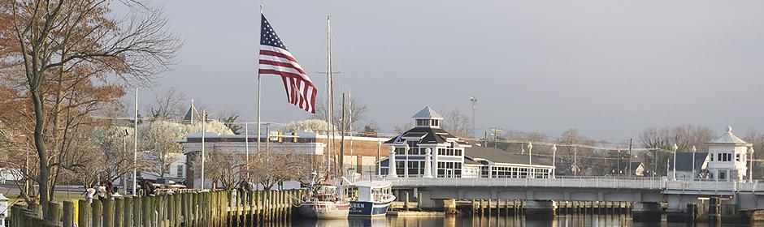

The officer’s and members of Pocomoke City #1624 have worked tirelessly preparing for this weekend’s event and we welcome our friends from throughout the Association. We are honored to host our Grand Exalted Ruler Randy Shook and First Lady Wanda as they visit our Association. Pocomoke City has not hosted a sitting Grand Exalted Ruler since 1986 and we are prepared to roll out the red carpet!
Should you need assistance of any kind or have questions about the local area, please feel free to reach out to any of our host committee members.

Welcome to Pocomoke! We hope your stay will be a memorable one!

Lodge GPS Address:
1944 Worcester Highway
Pocomoke City, MD 21851

SCHEDULE OF EVENTS
March 22nd (Friday)
11:00 AM – 4:00 PM Registration (Main Entrance)
12:00 PM – 2:00 PM Lunch (Lounge)
2:00 PM – 5:00 PM Scheduled Meetings (Ballroom)
6:00 PM – 8:00 PM Social Hour / Dinner (Lounge)
8:00 PM – until… “Keith White Duo”

March 23rd (Saturday)
7:30 AM – 4:00 PM Registration (Main Entrance)
7:00 AM – 9:00 AM Breakfast Buffet
8:00 AM – 9:00 AM Elks Camp Barrett Meeting (Ballroom)
9:00 AM – 12:00 PM Regular Meeting called to Order (Ballroom)
9:00 AM – 12:00 PM Ladies Entertainment (TBA)
12 noon – 2:00 PM Lunch
2:00 PM – 5:00 PM Committee Meetings (Ballroom)
5:30 PM – 6:30 PM Social Hour (Lounge & Ballroom)
6:30 PM – 8:30 PM Dinner in honor of GER Randy Shook (Coat & Tie)

8:30 PM – until… Dawn Williams (70’s & 80’s Rock, Pop, Country)
Vocals / Guitar / Sax / Flute
March 24th (Sunday)
7:30 AM – 9:00 AM Registration (Main Entrance)
7:30 AM – 9:00 AM Breakfast Buffet (Lounge)
9:00 AM – 12 noon Meeting called to Order (Ballroom)
12:00 noon – 2:00 PM Lunch (Lounge)

HOTEL INFORMATION
(RECOMMENDED)

Holiday Inn Express (2 miles / less than 5 minutes to Lodge)
125 Newtowne Blvd
Pocomoke City, MD 21851
(410) 957-6444
$129
Use “Elks Spring Workshop” when making reservations.

Hampton Inn & Suites Chincoteague Waterfront (20 miles / 25 minutes)

4179 Main St
Chincoteague, VA 23336
(757) 336-1616
$159
Use “Elks Spring Workshop” when making reservations

Fairfield Inn & Suites (20 miles / 25 minutes)

3913 Main St
Chincoteague, VA 23336
(757) 336-0043
$159
Use “Elks Spring Workshop” when making reservations

(Note – other hotels in Pocomoke City. We have negotiated special rates with those listed above)

LIMITED OVERNIGHT RV PARKING IS AVAILABLE AT THE LODGE. CALL AHEAD TO RESERVE

WORKSHOP MEALS

Friday, March 22, 2024

Lunch (Lounge) Bar Menu

Dinner (Lounge) Prepared by Pocomoke 1624 member Noah King

Smoked Pork BBQ, Eastern Shore Seasoned Brisket, Dublin Farms BBQ Chicken Breast, Cole Slaw, Potato Salad, Green Beans, Rolls ……$22
______________________________________________________________________________

Saturday, March 23, 2024

Breakfast Buffet (Lounge)

Sausage, Scrapple, Bacon, Scrambled Eggs, Pancakes, Hash Browns, Sausage Gravy, Biscuits, Cut Fruit ……………… $12

Lunch (Lounge)

Pocomoke Elk's Fried Chicken, Butter Poached Shrimp, Macaroni and Cheese, Green Beans, Seasoned Diced Potatoes ……........$15

Dinner (Ballroom) In honor of Grand Exalted Ruler Randy Shook and wife Wanda

Prepared by Pocomoke 1624 member Tom Wall

Herb Crusted Prime Rib, Saxis Island Crab Cake, Baked Potato, Seasoned Green Beans, Salad, Rolls ….………..$35
______________________________________________________________________________

Sunday March 24, 2024

Breakfast Buffet (Lounge)

Sausage, Scrapple, Bacon, Scrambled Eggs, Hash Browns, Sausage Gravy, Biscuits, Cut Fruit ………….……………………………………………………………………………$12

Lunch (Lounge)

Prime Rib Sandwich w/ Fries ………………………………………………………..……. $12
(Bar Menu also available)

Please contact our House Manager Lexi McNeel (757) 894-8501 with any special dietary needs.
MEAL RESERVATIONS – PLEASE REMIT PAYMENT BY MARCH 8TH, 2024

Friday

Lunch – Bar Menu Dinner $22 _____

Saturday

Breakfast $12 _____ Lunch $15 _____ Dinner $35 ______

Sunday

Breakfast $12 _____ Lunch $12 _____ (Bar Menu also available)

Total payment enclosed based upon selections: $ ______

Enclose payment with reservation and check payable to:

Pocomoke City Elks Lodge 1624
P.O. Box 174
Pocomoke City, MD 21851

NAME(S): ____________________________________________________

____________________________________________________

Address: ____________________________________________________

City / State / Zip: _______________________________________________

Telephone: _________________ Email: __________________

Lodge: _____________________

Any questions? Call / email C.L. Marshall 410-251-7341 or Wade Taylor 443-783-2870

secy1624@comcast.net
Lodge Drink Prices

Bottled Beer $3.00

Draft Beer $3.00

Craft Beer $4.00

Seltzers $3.75

Rail $4.25

Top Shelf $7.00

Wine $4.25

Fountain Drinks (Pepsi Products) $2.00

*** Prices subject to change ***

Churches
Abundant Life Apostolic Church Pitts Creek Baptist Church
110 Front St 653 Cedar Hall Rd
Sunday 9:30 AM Sunday 10:00 AM

Bayside Community Church Pitts Creek Presbyterian
Marva Theater 208 Market St
Sunday 10:00 AM Sunday 11:00 AM

Beaver Dam Christian Church First Baptist Church
345 Makemie Rd 204 4th St
Sunday 9:30 AM Sunday 11:00 AM

Bethany United Methodist Church Pocomoke River Church
205 Market St 1514 Market St
Sunday 11:30 AM Sunday 6:00 PM

Glad Tidings Assembly of God Saint John AME Church
1519 Market St 622 Cedar St
Sunday 11:00 AM Sunday 10:15 AM

Goodwill Baptist Church St. Mary’s Episcopal Church
3824 Stockton Rd 18 3rd St
Sunday 10:00 AM Sunday 10:15 AM

Holy Name of Jesus Parish Salem United Methodist Church
1913 Old Virginia Rd 500 2nd St
Saturday 5:00 PM / Sunday 11:00 AM Sunday 9:30 AM

Living Waters Inspirational Church Lynnhaven Baptist Church
2226 Bypass Rd 1200 Lynnhaven Dr
Sunday 10:00 AM Sunday 10:00 AM

HOST COMMITTEE MEMBERS

HOST CHAIRMEN: LODGE OFFICERS:
C.L. Marshall, PER Exalted Ruler Andy Clarke
410-251-7341 Leading Knight George Stevens
Loyal Knight Keith Aydelotte
Wade Taylor, PER Lecturing Knight Bob Donnelly
443-783-2870 Esquire Tim Corbin, PER
Secretary Wade Taylor, PER
REGISTRATION: Treasurer Carol Sullivan
Tim Abbott Inner Guard Chuck Bradford
757-894-1599 Tiler Chris Shay

ENTERTAINMENT: BOARD OF DIRECTORS
Lorie Northam Craig Glovier
410-430-8740 Willis Redden
Toby Tapman, Sr
HOUSING: C.L. Marshall, PER
C.L. Marshall, PER Eddie Holland
410-251-7341

DINING / LOUNGE:
Lexi McNeel, House Manager
757-894-8501

SET-UP / TEAR DOWN:
Keith Aydelotte
410-251-0179

