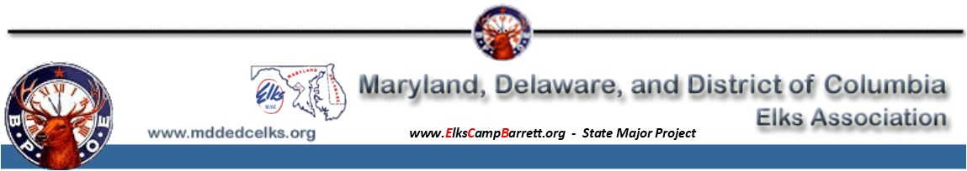
VOLUNTEER REGISTRATION FORM
ELKS NATIONAL CONVENTION
Baltimore, Maryland July 5-8, 2020

First Name |  |  |  |  |  |  |  |  |  |  | Last Name
Spouse (for guest registration) |  |  |  |  |  |  |  |  |  |  | (If spouse is also a volunteer, use separate form)
Lodge Name & Number |  |  |  |  |  |  |  |  |  |  |  |  |  |  | Membership No.
Highest/Current Grand Lodge or Lodge Office
Address |  |  |  |  |  |  |  |  | City/State |  |  |  |  |  |  |  | ZIP
Best Phone |  |  |  |  |  | 2nd Phone |  |  |  |  |  |  | E-mail
Additional Comments or Work Preference *
Any Work Limitations

Staffing needs:

Airport Greeting | Standing | (1st Mon, Tue and Wed)
Registration | Standing and Sitting | (Sat and Sun, a few Fri, Mon and Tue)
Ushering | Standing | (Sun PM, Mon thru Wed AM)
Ritual | Standing and Sitting | (Fri thru Tue)
Legislative | Standing and Sitting | (Tue morning)
Manpower Room | Sitting, Errands | (Fri thru Tue)

Please Check All Days You Can Work

JULY |  |  |  |  |  |  |  |  |  |  |  | JULY
Mon |  | Tue |  | Wed |  | Thur |  | Fri |  | Sat |  | Sun |  | Mon |  | Tue |  | Wed
 |  |  |  | 1st |  | 2nd |  | 3rd |  | 4th |  | 5th |  | 6th |  | 7th |  | 8th

*Your Membership Number is Required:
…to have your convention registration fee waived. Volunteers are not “paid” and are responsible for their expenses, including travel and hotel.

Exalted Rulers or Lodge Representatives, and DDGER-designates are not eligible for waived registration fees, but are still welcome to assist!

Register by mail, email or fax:
Vincent A. Pingitore, Jr., PSP
MD-DE-DC Host Committee Registration Chair
12200 Peabody Ln., Charlotte Hall, MD 20622-3725
Email: vinniep@hughes.net
Phone: 301-704-8323

General Chairman: Warren H. Johnson, BOGT
Email: johnsoncomputer@verizon.net
Cell: 301-606-6133

