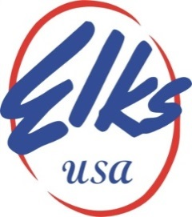

MEDIA ALERT

A Fraternal Organization
2750 N. Lakeview Avenue, Chicago, IL 60614-1889

Contact: Rick Gathen FOR IMMEDIATE RELEASE
Phone: (862) 324-2412

ELKS LOVE A PARADE

The Elks are in the Tournament of Roses Parade

Chicago, IL – For the first time since 1995, the Elks will have a float in the Tournament of Roses Parade in Pasadena, California, on January 2, 2023. The Elks Tournament of Roses parade float allows our members across the nation to show their pride and share in the excellent work being done by the BPOE to promote the organization's mission and values. Local Elks Lodges from every state nationwide, Guam, Puerto Rico, the Philippines, and the Panama Canal Zone, will be watching the parade. Please visit BPO Elks USA to see graphics which depict past Elks floats in the parade.

The Elks have been busy helping our communities this holiday season. Thousands of financially struggling families will receive food baskets and presents. Elk volunteers will visit thousands of hospitalized Veterans who have protected our freedoms. The Elks vow, “So long as there are Veterans, the Benevolent and Protective Order of Elks will never forget them.” The Elks support both active military forces and Veterans. Elks furnish food, comfort care, therapeutic items, and gifts, host holiday celebrations and recreational activities at bases and hospitals, and stand ready to fulfill any need. Last year alone, the value of Elks’ contributions to the nation’s heroes provided more than $39 million to more than 300 Veterans Administration Medical Centers, clinics, and state care facilities.

The Elks will receive thousands of scholarship applications in December from high school seniors nationwide, with nearly $5 million distributed annually. The Elks Community Investment Program will award almost $16 million towards enriching our communities. Elks Lodges nationwide donated more than $368 million last year to the communities they serve throughout the United States and its territories.

There are nearly 1,800 Elks Lodges across the country, with a total membership of around 800,000. Elk’s members must be American citizens who are at least 21 years of age and must believe in God. To learn more and to join us in service, visit www.elks.org. For membership information, visit Join.Elks.Org.

