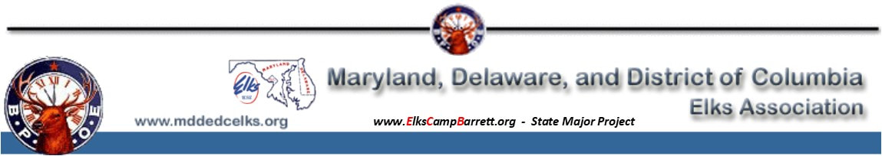
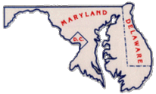
David E. Wolcott was born on February 5, 1949 in Easton, MD, and he was a Civil Engineer by trade. In 1979, he married the love of his life, Connie Wolcott and they enjoyed 36 years of marriage before her passing on April 22, 2015. Dave passed shortly thereafter on August 6, 2015.
Dave was initiated into the Benevolent and Protective Order of Elks on January 23, 1986.
He was a leader by example as well as in title. He not only served in his own lodge, Easton #1622, but also served in many positions for the Maryland, Delaware & District of Columbia State Elks Association.
Dave was an Elk that really made an effort to live by the principles of our Order…
Charity, Justice, Brotherly Love and Fidelity. Extremely Patriotic, he was quick to remind us of the importance of our flag as the symbol of our Nation and our responsibility to the folks that served in our Armed Forces. He often reminded us of our duty to foster a spirit of Patriotism and Americanism in our community.
Early in 2015, the Maryland, Delaware and District of Columbia State Association began plans to implement an Army of Hope. The purpose of the Army of Hope would be to assist all currently serving active-duty military and reserve personnel, those wounded and the families of our Fallen Heroes. Dave knew funding for this committee would be needed. His love and admiration for this group of service people and their families inspired him to come up with a plan to do just that.
With the encouragement and support of his wife, Connie, also an extraordinary Elk, he purchased a 1955 Ford 2 Dr Crown Victoria which he donated to the Maryland, Delaware and District of Columbia State Association to raffle off for the purpose of raising the needed funds. His dream of increasing service to our veterans and servicemen and women through implementation of The Army of Hope program was becoming a reality.
Shortly before his death, he requested that our State Association go forward with this dream of his. He felt confident that our Membership would embrace this additional service to those who have served us and their families as we continue to enforce our mantra “So long as there are Veterans, the Benevolent and Protective Order of Elks will never forget them”.

As we march forward with Dave’s dream, please keep in mind that the Benevolent and Protective Order of Elks is a strictly volunteer organization, and all proceeds from this raffle will be used strictly for the purpose of benefitting those served by the Army of Hope, with no administrative costs.
Let us make Dave’s Dream a Reality!!

