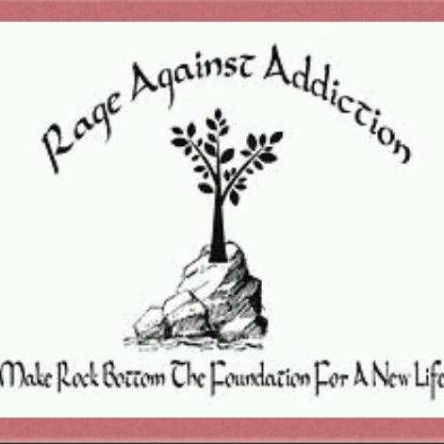
ARE YOU UP FOR A NEW CHALLENGE?
Join Rage Against Addiction Virtual Memory Walk/Run
2021!!!
When: APRIL 1st through APRIL 30th.
Where: ANYWHERE

Log your miles and see how you stack up to the competition.
You can register as a runner/walker, and/or create a fundraiser.
Remember those lost to addiction.
Honor those in recovery.
Help those still struggling.
What better way to enjoy the fresh air and get active than to support a great cause?

REMEMBER NO FAMILY IS IMMUNE!
Register at: https://runsignup.com/rageagainstaddiction
Remember to let them know that you are an Elk member.

